Q-1:



Sol-1:

public class Solution {

public static void nForest(int n) {

for(int i=0; i<n; i++){

for(int j=0; j<n ; j++){

System.out.print("\*"+ " ");

}

System.out.println();

}

}

}

Q-2:



Sol-1:

public class Solution {

public static void nForest(int n) {

// Write your code here

for(int i=0; i<n; i++)

{

for(int j=0; j<n; j++){

if(j==0 || i==(n-1) || i>=j){

System.out.print("\*" + " ");

}

else{

System.out.print(" ");

}

}

System.out.println();

}

}

}

Sol-2:

public class mysirg {

public static void main(String[] args) {

for(int i=1; i<=5;i++){

for(int j=1; j<=5; j++){

if (j<=i) {

System.out.print("\*");

}

else{

System.out.print(" ");

}

}

System.out.println();

}

}

}

Q::

\*

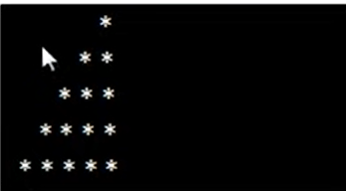

Soln:

public class mysirg {

public static void main(String[] args) {

for(int i=1; i<=5;i++){

for(int j=1; j<=5; j++){

if (j>=6-i) {

System.out.print("\*");

}

else{

System.out.print(" ");

}

}

System.out.println();

}

}

}

Q::

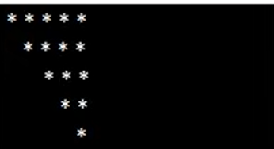

Code:

public class mysirg {

public static void main(String[] args) {

for(int i=1; i<=5;i++){

for(int j=1; j<=5; j++){

if (j>=i) {

System.out.print("\*");

}

else{

System.out.print(" ");

}

}

System.out.println();

}

}

}

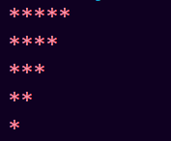

Code:

public class mysirg {

public static void main(String[] args) {

for(int i=1; i<=5;i++){

for(int j=1; j<=5; j++){

if (j<=6-i) {

System.out.print("\*");

}

else{

System.out.print(" ");

}

}

System.out.println();

}

}

}

Q–

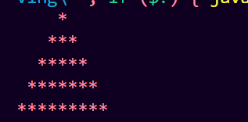

Code:

public class mysirg {

public static void main(String[] args) {

for(int i=1; i<=5;i++){

for(int j=1; j<=9; j++){

if (j>=6-i && j<=4+i) {

System.out.print("\*");

}

Else{

System.out.print(" ");

}

}

System.out.println();

}

}

}

Q::



Code:

public class mysirg {

public static void main(String[] args) {

int k;

for(int i=1; i<=5;i++){

for(int j=1; j<=9; j++){

if (j>=6-i && j<=4+i && j%2==i%2) {

System.out.print("\*");

}

else{

System.out.print(" ");

}

}

System.out.println();

}

}

}

Q::

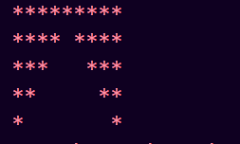

SOLN:

public class mysirg {

public static void main(String[] args) {

for(int i=1; i<=5;i++){

for(int j=1; j<=9; j++){

if (j<=6-i || j>=4+i ) {

System.out.print("\*");

}

else{

System.out.print(" ");

*// k=1;*

}

}

System.out.println();

}

}

}

Q::



Code:

public class mysirg {

public static void main(String[] args) {

int n= 6;

for(int i=1; i<=n;i++){

for(int j=1; j<=2\*n-1; j++){

if (j>=i && j<=2\*n-i ) {

System.out.print("\*");

}

else{

System.out.print(" ");

}

}

System.out.println();

}

}

}

Q-3:

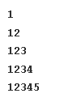

Sol-1:

public class demo {

public static void main(String[] args) {

int n=11;

for(int i=1; i<=n; i++)

{

for(int j=1; j<=n; j++){

*// write i==(n) instead of i==(n-1) becoZ i=1; i<=n (1 to 11) --i==(n)==11*

*// i=0; i<n (0 to 10) -- i==(n-1)=11*

if( i>=j || j==0 || i==(n)){

System.out.print(j + " ");

}

else{

System.out.print(" ");

}

}

System.out.println();

}

}

}

Sol-2:

public class Solution {

public static void nTriangle(int n) {

// Write your cde here

for(int i=1; i<=n; i++){

for(int j=1; j<=i; j++){

System.out.print(j + " ");

}

System.out.println();

}

}

}

Q-4:

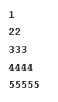

Sol-1:

public class demo {

public static void main(String[] args) {

int n=11;

for(int i=1; i<=n; i++)

{

for(int j=1; j<=n; j++){

*// write i==(n) instead of i==(n-1) becoZ i=1; i<=n (1 to 11) --i==(n)==11*

*// i=0; i<n (0 to 10) -- i==(n-1)=11*

if( i>=j || j==0 || i==(n)){

System.out.print(i + " ");

}

else{

System.out.print(" ");

}

}

System.out.println();

}

}

}

Sol-2:

public class Solution {

public static void nTriangle(int n) {

// Write your code here

for(int i=1; i<=n ; i++)

{

for(int j=1 ; j<=i; j++){

System.out.print(i + " ");

}

System.out.println();

}

}

}

Q-5:



Sol-1:

public class demo {

public static void main(String[] args) {

int n=11;

for(int i=0; i<n; i++)

{

for(int j=0; j<n; j++){

if( i+j<=(n-1)){

System.out.print("\*" + " ");

}

else{

System.out.print(" ");

}

}

System.out.println();

}

}

}

Soln-2:

public class Solution {

public static void seeding(int n) {

*// For loop 'row' in range 0 to N-1.*

for(int row = 0; row < n; row++)

{

*// For loop 'col' in range 0 to row.*

for(int col = 0; col < n; col++)

{

*// If 'col' < N-'row', print a '\*'.*

if(col < (n-row))

{

System.out.print("\* ");

}

}

System.out.println();

}

}

}

Q-6:

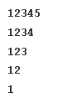

Sol-1:

public class Solution {

public static void nNumberTriangle(int n) {

// Write your code here

for(int i=1; i<=n; i++)

{

for(int j=1; j<=n; j++){

if( i+j<=n+1){

System.out.print(j + " ");

}

else{

System.out.print(" ");

}

}

System.out.println();

}

}

}

Detail explaination:

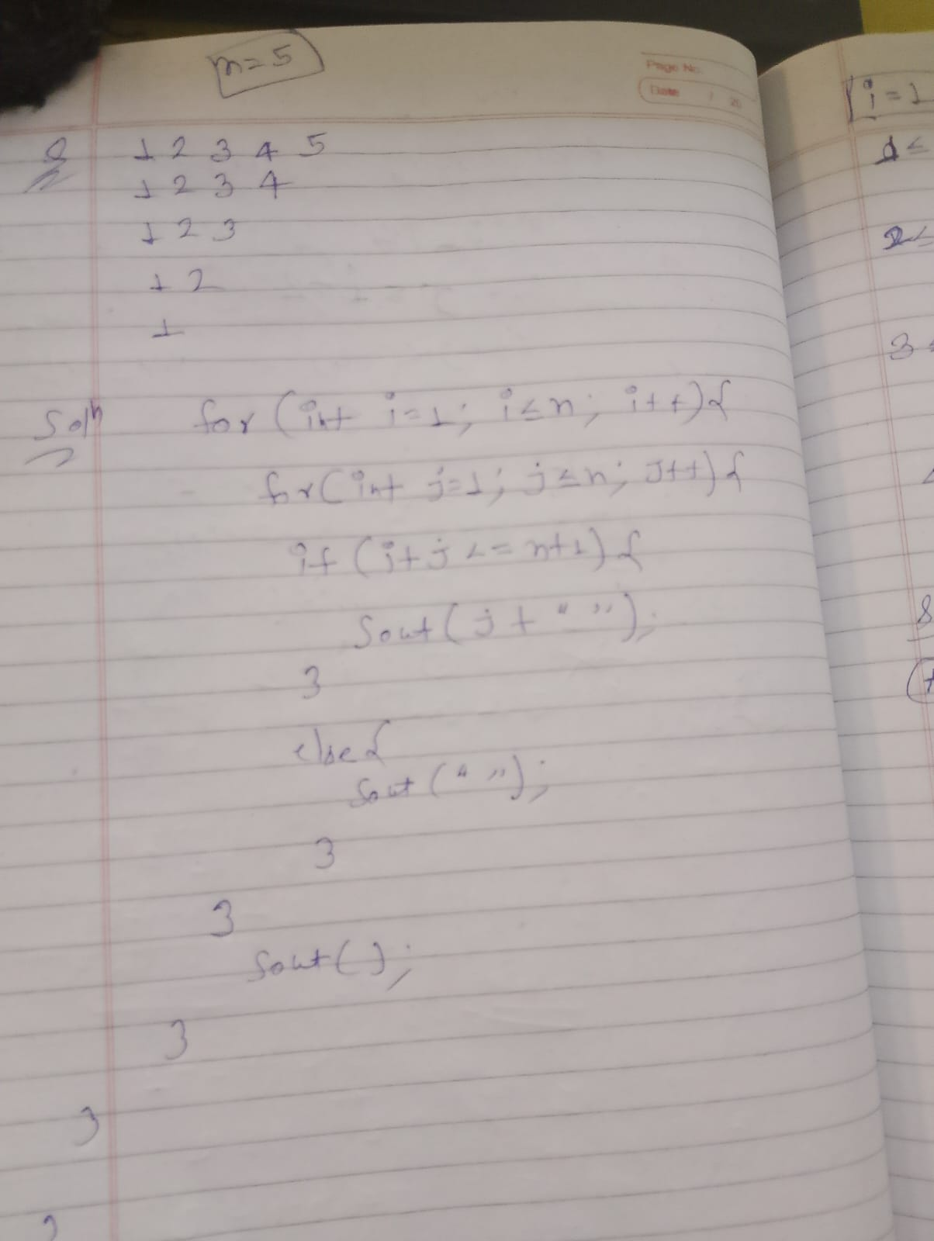

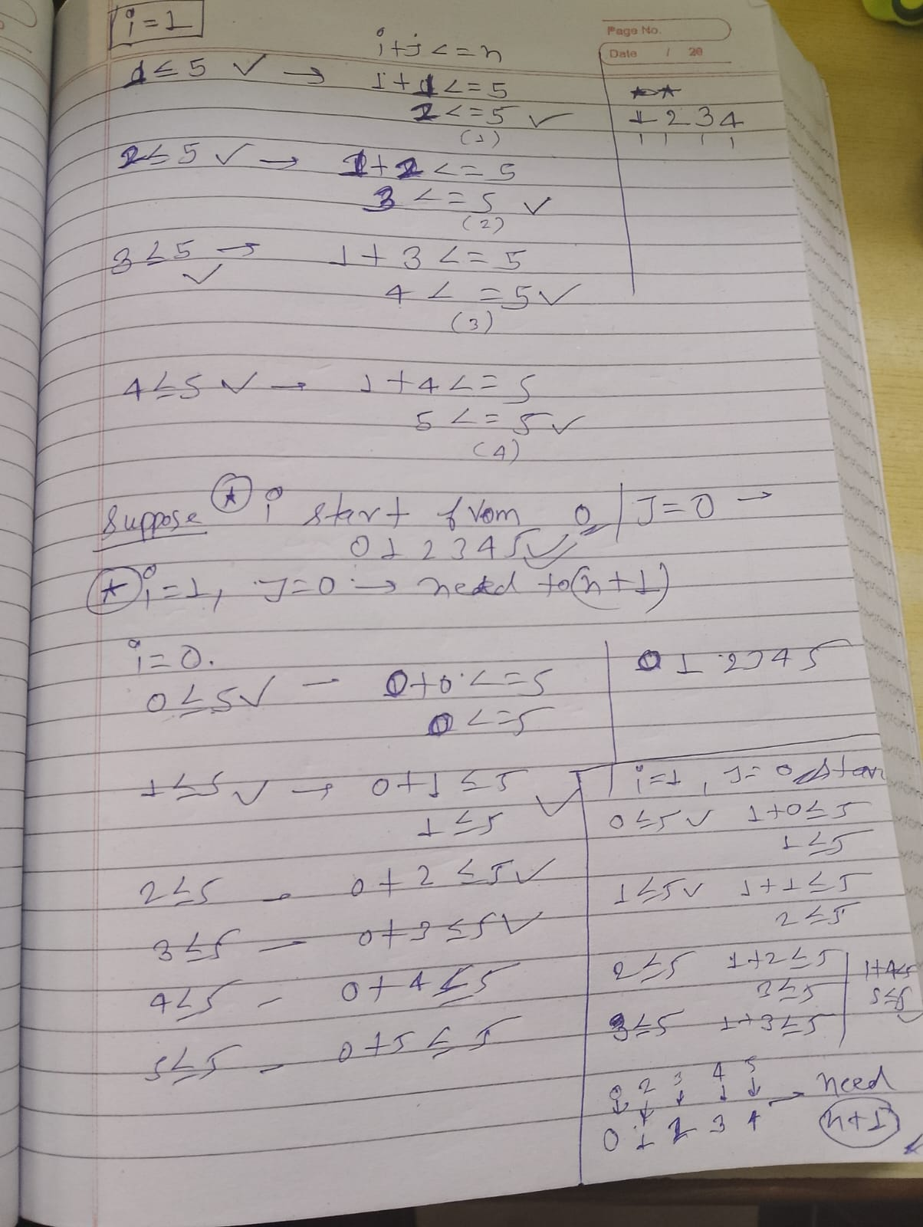

Sol-2:

public class Solution {

public static void nNumberTriangle(int n) {

// Write your code here

for(int i=1; i<=n; i++){

for(int j=1; j<=n-i+1;j++){

System.out.print(j+ " " );

}

System.out.println();

}

}

}

Q-7 :



Sol-:

public class demo {

public static void main(String[] args) {

int n=4;

for(int i=0; i<n; i++)

{

for(int j=0; j<2\*n; j++){

if( i+j>=2\*(n-1)/2 && i<=2\*(n-1)/2 && j-i<=2\*(n-1)/2 ){

System.out.print("\*" );

}

else{

System.out.print(" ");

}

}

System.out.println();

}

}

}

Q-8:



Sol:

public class ano {

public static void main(String[] args) {

int n=4;

for(int i=0; i<=2\*n; i++)

{

for(int j=0; j<=2\*n; j++){

if (j>(2\*n)/2 && j-i<=(2\*n)/2 && i+j<=(2\*n)+(2\*n)/2)

{

System.out.print("\*" );

}

else{

System.out.print("");

}

}

System.out.println();

}

}

}

Q-19:



Sol-1:

public class Solution {

public static void symmetry(int n) {

*// Write your code here*

for(int i=0; i<2\*n; i++)

{

for(int j=0; j<2\*n; j++){

if ( j==0 || j==(2\*n-1) || i==0 || i==(2\*n-1) ||i+j<=(2\*n-1)/2 || j-i>(2\*n-1)/2 || i-j>(2\*n-1)/2 || i+j>(2\*n-1) +(2\*n-1)/2 )

{

System.out.print("\*" + " " );

}

else{

System.out.print(" ");

}

}

System.out.println();

}

}

}

Q::

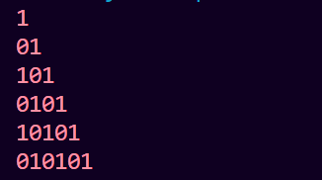

Code:

public class demo {

public static void main(String[] args) {

for(int i=1; i<=6; i++){

for(int j=1; j<=i; j++){

if (i%2==j%2) {

System.out.print("1");

}

else{

System.out.print("0");

}

}

System.out.println();

}

}

}

Q:

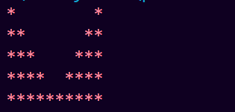

Code:

public class demo {

public static void main(String[] args) {

int n=5;

for(int i=1; i<=n; i++){

for(int j=1; j<=2\*n; j++){

if ( j<=i || j>=2\*n+1-i ) {

System.out.print("\*");

}

else {

System.out.print(" ");

}

}

System.out.println();

}

}

}

Q:

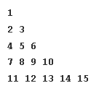

Code:

public class demo {

public static void main(String[] args) {

int n=5;

int c=1;

for(int i=1; i<=n ; i++)

{

for(int j=1; j<=i; j++)

{

System.out.print(c );

c++;

}

System.out.println();

}

}

}

Q::

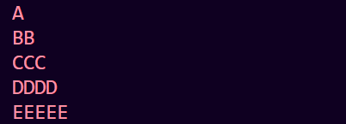

Code:

public class demo {

public static void main(String[] args) {

*// int n=5;*

char ch = 'A';

for(int i=1; i<=5 ; i++)

{

for(int j=1; j<=i; j++)

{

System.out.print(ch );

}

System.out.println();

ch++;

}

}

}

Q::

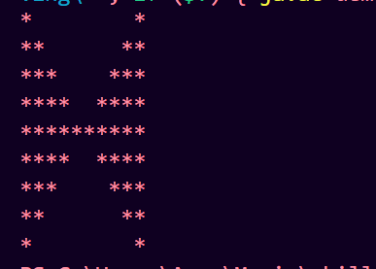

Code:

for(int i=1; i<=2\*n-1 ; i++)

{

for(int j=1; j<=2\*n; j++)

{

if ( j<=i && j<=2\*n-i || j>=2\*n+1-i && j>=i+1) {

System.out.print("\*" + " " );

}

else{

System.out.print(" ");

}

}

System.out.println();

}